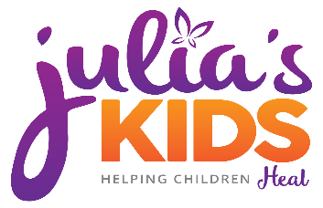
Contact:
Yolande McCray
Julia’s Kids Incorporated
(954) 800-3953
ymccray@juliaskids.org

Julia’s Kids Incorporated Celebrates GivingTuesday by joining millions around the world participating in the global generosity movement

December 3rd, 2019 is GivingTuesday and Julia’s Kids Incorporated needs your help.

Julia’s Kids was founded in August 2015 after my dear friend Julia was killed. While mentoring to her three children, I noted that there was a deficit in the types of grief support available to them in the community. Julia’s Kids mission is to create a stable, safe place for youth to discuss their feelings and learn coping mechanisms after a loss. We host monthly “group chats”, a Reality Check Workshop, Family Summit on Loss and Wellness and offer a scholarship opportunity high school seniors.

GivingTuesday is a global generosity movement that was launched in 2012 as a simple idea: to create a day that encourages people to do good. Over the past seven years, this idea has grown into a global movement that inspires hundreds of millions of people to give, collaborate, and celebrate generosity

We are asking for you to be generous to us!!

Donations to Julia’s Kids are utilized to facilitate the programs held at our Resource Center in Miami Gardens and assist with offsetting cost for families that cannot afford private therapy sessions.

Your dollars at work:
Monthly rent for Resource Center $980
Sponsor a monthly group session $200
Sponsor a private therapy session $70
Sponsor a coping activity $60

Those who are interested in joining Julias’s Kids GivingTuesday initiative can visit www.juliaskids.org.

Warm Regards,
Yolande McCray
Founder and CEO

